Empirical Big-O Values

Empirical /em·pir·i·cal/ based on, concerned with, or verifiable by observation or experience rather than theory or pure logic. Synonyms: experiential, practical, heuristic, firsthand, hands-on.

You will collect data and confirm the Big-O values of our four sorts for best case, average case, and worst case. Open EmpiricalBigO.jar. The executable jar file allows you to make choices as to the n, the type of sort, and the order of the data. The panel will display the elapsed time to complete the sort. To help you record your data, I have provided an Excel spreadsheet called EmpiricalBigO.xls. What data do you need to collect? Do some planning below:

- Using Random data, design an experiment, collect data, and make a graph confirming that
  - Selection Sort’s average case is O(n²).
  - Insertion Sort’s average case in O(n²).
  - Merge Sort’s average case is O(n log n).
  - Quick Sort’s average case is O(n log n).

 | 500 | 1000 | 2000 | 4000 | 8000
Selection | 176 | 469 | 1677 | 6345 | 28465
Insertion | 90 | 214 | 520 | 3336 | 14045
Merge | 52 | 105 | 211 | 464 | 1210
Quick | 79 | 91 | 185 | 485 | 972

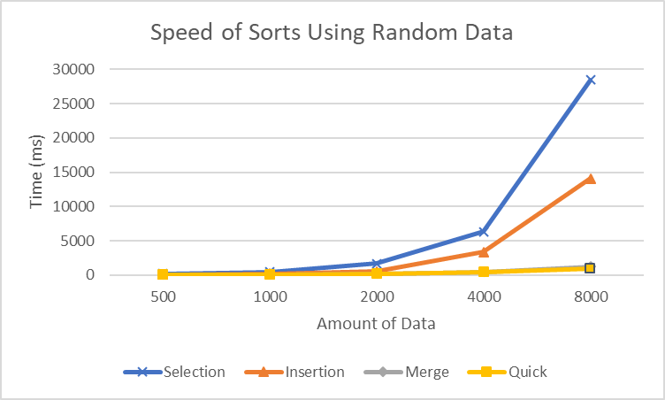

- Selection sort: design an experiment, collect data, and make a graph showing the Selection Sort’s
Big-O’s on Random data, Ascending data, and Descending data.
Conclusion: Selection Sort’s best case Big-O is __________ on _________
average case Big-O is __________ on _________
worst case Big-O is ________ on ___________
 | 500 | 1000 | 2000 | 4000 | 8000
Random | 176 | 469 | 1677 | 6345 | 28465
Ascending | 167 | 460 | 1576 | 6324 | 29003
Descending | 164 | 459 | 1632 | 6421 | 28967

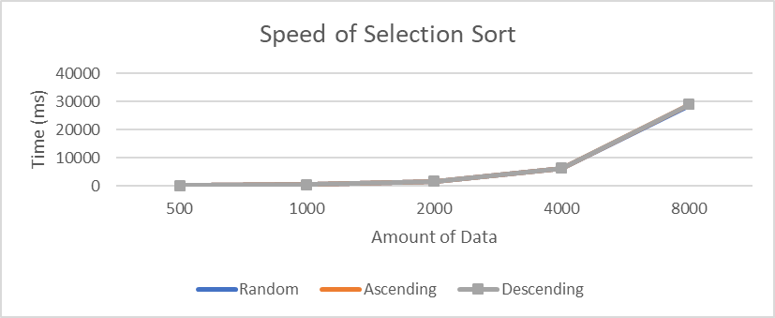

- Insertion sort: design an experiment, collect data, and make a graph showing the Insertion Sort’s
Big-O’s on Random data, Ascending data, and Descending data.
Conclusion: Insertion Sort’s best case Big-O is __________ on _________
average case Big-O is __________ on _________
worst case Big-O is ________ on ___________
 | 500 | 1000 | 2000 | 4000 | 8000
Random | 90 | 214 | 520 | 3336 | 14045
Ascending | 1 | 1 | 5 | 14 | 37
Descending | 122 | 424 | 1954 | 7562 | 30546

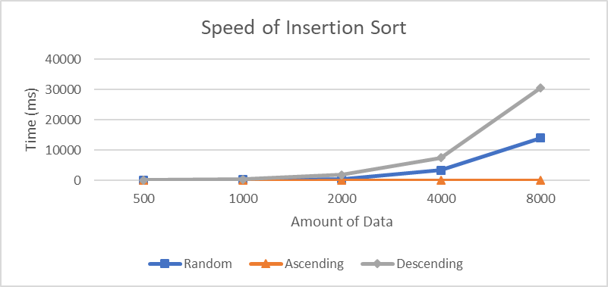

- Merge Sort: design an experiment, collect data, and make a graph showing the Merge Sort’s Big-O’s on Random data, Ascending data, and Descending data.
Conclusion: Merge Sort’s best case Big-O is __________ on _________
average case Big-O is __________ on _________
worst case Big-O is ________ on ___________
 | 500 | 1000 | 2000 | 4000 | 8000
Random | 52 | 105 | 211 | 464 | 1210
Ascending | 26 | 58 | 154 | 287 | 499
Descending | 26 | 57 | 155 | 220 | 336

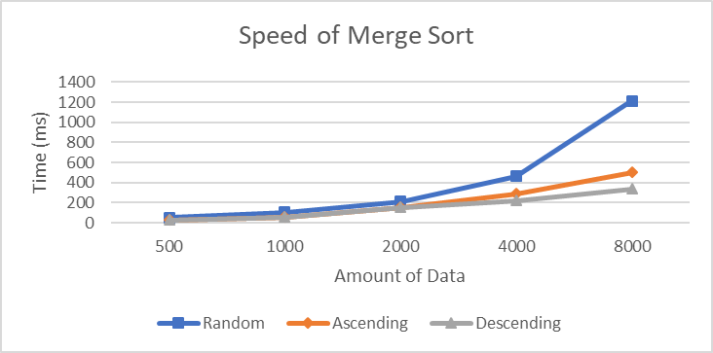

- Quick Sort, in which the pivot is the first element: design an experiment, collect data, and make a graph showing the Quick Sort’s Big-O’s on Random data, Ascending data, and Descending data.
Conclusion: if the pivot is the first element, the Quick Sort’s
best case Big-O is __________ on _________
average case Big-O is __________ on _________
worst case Big-O is ________ on ___________
 | 500 | 1000 | 2000 | 4000 | 8000
Random | 79 | 91 | 185 | 485 | 972
Ascending | 272 | 1035 | 2697 | 8655 | 11139
Descending | 268 | 1106 | 4910 | 21637 | 79778

